4.3 Converting column data types

Dataflow Gen2
In a Dataflow Gen2, you can change the column data type by right-clicking on a column, clicking Change Type, like this:
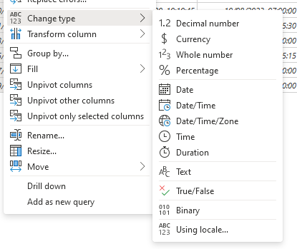
Most of the Types above are self-explanatory, Using Locale is an interesting one to convert string values into a Date or DateTime, taking into consideration the formating of the DateTime in the string.

T-SQL Data Warehouse
Using T-SQL, you can CAST a column from one data type to another:
SELECT CAST(ROUND(SalesYTD / CommissionPCT, 0) AS INT) AS Computed
FROM Sales.SalesPerson
WHERE CommissionPCT != 0;
You can also use CONVERT:
SELECT TOP(1)
SYSDATETIME() AS UnconvertedDateTime,
CAST(SYSDATETIME() AS NVARCHAR(30)) AS UsingCast,
CONVERT(NVARCHAR(30), SYSDATETIME(), 126) AS UsingConvertTo_ISO8601
FROM dbo.DimCustomer;
CONVERT is particularly useful for Datetime conversion in different formats.

